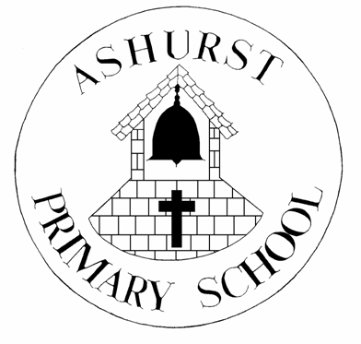
ASHURST CE AIDED PRIMARY SCHOOL

PARISH NEWSLETTER

AUTUMN TERM 2019

Welcome to the new academic year at Ashurst Primary School and to the first of the school’s termly Newsletters, written once again for the Parish Magazine by pupils in Y6 (for the most part).

At the start of September, the whole school took part in our Annual Sponsored Walks raising money for Charities chosen by the pupils. This year ‘Save the Rainforest’ and ‘The World Wild Life Fund’ were chosen by Y5&6, ‘Cancer Research’ and ‘The World Land Trust’ by Y3&4, and the RSPCA selected by FS, Y1&2.

Each walk was blessed with glorious sunny weather. Y5&6 pupils were the first to take the minibus journey to our starting point by the banks of the River Adur at Shoreham Airport on 13th September, Y3&Y4’s was 20th September, followed by FS, Y1&Y2 on 17th September. All groups enjoyed a brief stop at the terminal for the airport, a fascinating Art Deco building with many historical artefacts and displays to see. We were lucky enough to be treated to some welcome ‘gingerbread men’ from Truffles restaurant to help us on our way. Thank you to the Truffles staff, and the kind people who donated to our charities as we headed out on our walks.

Making our way along the banks of the river, we enjoyed the remarkable scenery all around us, including the Southdowns’ hills stretching out in the distance, the river shimmering in the sunlight, the rooftop spires of Shoreham College in front and the patchwork of roads and railways in the distance. We watched as aeroplanes, helicopters, trains, cars and even boats made their own journeys along side us. Wildlife was abundant too, with seagulls and wading birds enjoying the breeze along the river banks. Y3/4 & Y5/6 pupils’ walks included a visit to St.Nicholas’ Church at Shoreham, with the coolness and quietness of the church being most welcome after the heat of the sun outside. We made time for some quiet reflection and sketching whilst we were there.

Returning to school pupils wrote about their journeys and experiences, with Y5& Y6 recounting events through the eyes of a helicopter pilot flying above our meandering route.
Y6 pupil Lucy:
As I strode away from the Truffle lunch truck, I was munching on a cheese and ham toastie and humming my favourite tune. I was already in my flight gear and wore a headpiece that buzzed like a fat, black fly in my ear. Then I stepped into the gleaming navy coloured helicopter, whacking my head on the doorframe!
I flicked four silver switches in a row and pulled a lever on my left. “Ready for take off, over”, I declared.
“Copy that, commence take off in three”, the communication tower replied.
I then did a final check that my emergency parachute was with me and that my door was closed.
I felt as though my heart rate was at the same speed as the constant whoosh of the propellers as I gradually rose from the ground. I felt like I was flying as freely over the fields as a bird with a good spirit. As I arrived at my height limit I could see the rippling reflection of my helicopter on the water below. I drew near to Lacing College and noticed how the golden rays of sunlight shone on the chapel below and it appeared to glow!
I could see someone fishing and someone canoeing down the river.

After noticing the busy veins of traffic along the A27, I decided to trail above a person on a run which led me to St Nicholas’ Church with its golden cockerel on the spire and then on my way back I noticed a set of silver arches, with different things on each arch representing the Shoreham Air Disaster in 2015.
Time to return to base…..

A fascinating account we think you will agree! Thank you, Lucy.
As we go to press Harvest has just been celebrated in school and at St. James’ Church, we are still humming our favourite hymn…’Cauliflowers fluffy and cabbages green, strawberries sweeter than any I’ve seen………’.
We are looking forward to all of the exciting things to come in the next few weeks including Open Afternoons, Christmas celebrations - such as the Nativity and Christingle service, and the REMEMBRANCE SERVICE presented by Y3& Y4 pupils to be held in school on Thursday 14th November, 10:30am, to which local residents are warmly invited.
Thank you, as always, for your continued support, and we look forward to welcoming you to our school events and special occasions throughout the 2019-2020 academic year.

