Ashurst CE Aided Primary School
warmly invites you to

A Present for the Baby
by Mouse Class
on
Thursday 14th December at 9.15am
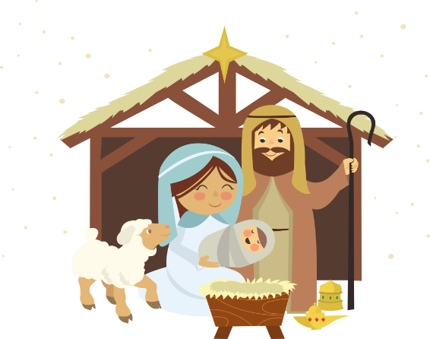

*************************************
Allocation of tickets
Mouse families: 2 tickets per family

Owl and Squirrel families will be allocated any remaining tickets

Please complete and return the attached slip for tickets by Friday 1st December 2023

A Present for the Baby
by Mouse Class
Family name:

We would like tickets for:
(please indicate number required in the boxes)
Thursday 14th December 9.15am
Signed:

***********************************************

