Ashurst CE Primary School Appraisal Policy Guidance
(based on WSCC model policy guidance)
Contents

- Introduction
- The Appraisal Cycle
- The Appraisal Cycle – Additional Points
- The Main Roles And Responsibilities In Appraisal
- Reducing Appraisal Process Workload
- Professional Development – Teaching
- Informal Support
- Reviewing Performance
- Document History

1. Introduction
The following notes are based on the document Teacher Appraisal Guidance For Schools which applies to teachers, including school leaders, but the principles of appraisal are similar for all school staff and the Model Appraisal Policy has been written with all school staff in mind. In addition, it has been written in the context of schools, but the same principles apply to Centrally Employed Teachers. With this in mind this guidance document generally refers to ‘employee’ or ‘employees’ unless the details covered are specific to teachers.

Appraisal arrangements for schools are set out in the Education (School Teachers’ Appraisal) (England) Regulations 2012 (the Appraisal Regulations).

The Appraisal Regulations set out the principles that apply to teachers in all maintained schools and Centrally Employed (or unattached) Teachers employed by a local authority, in each case where they are employed for one term or more.

The Appraisal Regulations do not apply to any teacher undergoing an induction period or are subject to capability procedures.

Maintained schools and local authorities must stay within the legal framework set out in the Appraisal Regulations, and all schools (including academies) must adhere to any other relevant legislation that affects all employers (for example legislation on equality, employment protection and data protection).

The appraisals process should be intrinsically supportive and developmental, conducted within a school culture that values openness and fairness. Appraisal should be a non-bureaucratic process that recognises, encourages, and validates an employee’s commitment to professional development, effective performance, and for teachers pedagogical excellence.

It should offer a supportive and safe environment where individual employees and their line managers can have open and honest conversations about successes and areas for improvement. It should also address the support that will be provided to enable all employees to achieve their objectives and in the case of teachers continue to meet the teacher’s standards.

Reducing unnecessary workload should be at the forefront of any considerations around implementing appraisal processes in schools.

Where there are concerns about aspects of the employee’s work performance, at any point throughout the appraisal process, they should receive informal focused support. In most cases this should be separate and come before any capability procedures are considered. This might include mentoring, training, or resources to address specific needs.

Employees should normally only enter capability procedures when there is unsatisfactory progress made with their work performance that the appraisal process, including the informal support mechanisms have been unable to address. Details of the school’s capability procedure are covered in the Capability Policy.

It is important that the appraisal is managed in a way that avoids increased workloads for all parties concerned, for example, reviewing the number and frequency of meetings and observations, and ensuring the process for collecting evidence is always proportionate.

2. The Appraisal Cycle
The details below set out the key elements that should be adhered to during the appraisal process, which spans the academic year. In addition to these key elements, employees will benefit from regular and ongoing dialogue with their line manager throughout the appraisal cycle to support their development, performance, and wellbeing.

Autumn term
- All objectives, success criteria, and evidence to be used will be finalised between the appraiser (e.g., the headteacher/line manager) and appraisee (e.g., the teacher, or member of the support staff). If agreement cannot be reached, objectives are set by the appraiser. The appraisee can record their disagreement in writing which should then be taken into account at the review stage.

Spring term
- Performance is reviewed against objectives and standards as set out in the school’s Appraisal Policy (e.g., through lesson visits, ongoing professional dialogue between the relevant parties, and interim reviews).

Additional support can be provided if a need is identified at any point in the appraisal cycle, and this should be documented. Refer to the Informal Support section of Appraisal Policy.

Autumn term
At the end of the appraisal year, employees must receive an appraisal report which includes (amongst other things) an assessment against their objectives and success criteria and the relevant standards.

In addition to assessing an employee’s achievement of objectives, it is important for line managers to also discuss workload, wellbeing, working hours, flexible working opportunities, and career aspirations in a supportive manner. This can help the employee identify strategies to effectively manage their workload and wellbeing, as well as provide feedback to management for further improvement and retention.

The appraisals process should be intrinsically supportive and developmental, conducted within a school culture that values openness and fairness. Throughout the appraisal cycle, teachers should receive informal feedback on their performance and development areas. There should be early dialogue with employees that have emerging performance issues, with prompt support put in place to ensure they have the appropriate guidance and opportunity to improve in the relevant areas.

3. The Appraisal Cycle – Additional Points
The appraisal cycle (sometimes referred to as the appraisal period) will usually be 12 calendar months, aligned to the Academic Year, but it may be aligned to another time period to reflect school priorities. There are certain exceptions to this:

- For staff who start employment part way through an appraisal period, the Headteacher, or in the case where the employee is the Headteacher, the Governing Body, will determine the length of the first appraisal period with a view to bringing them in line with the appraisal cycle for other staff as soon as possible.
- Where an individual transfers to a new post within the school part way through the cycle, the Headteacher, or if the employee is the Headteacher, the Governing Body, will determine whether the appraisal period will begin again and whether to change the appraiser.
- It is mandatory that the appraisal period for a teacher on a fixed term contract is determined by the duration of the contract.

4. The Main Roles and Responsibilities in Appraisal

School leaders, governing bodies and teachers all have a role to minimise burdens on their staff, including in relation to paperwork and evidence collection

The following table illustrates the arrangements for maintained schools
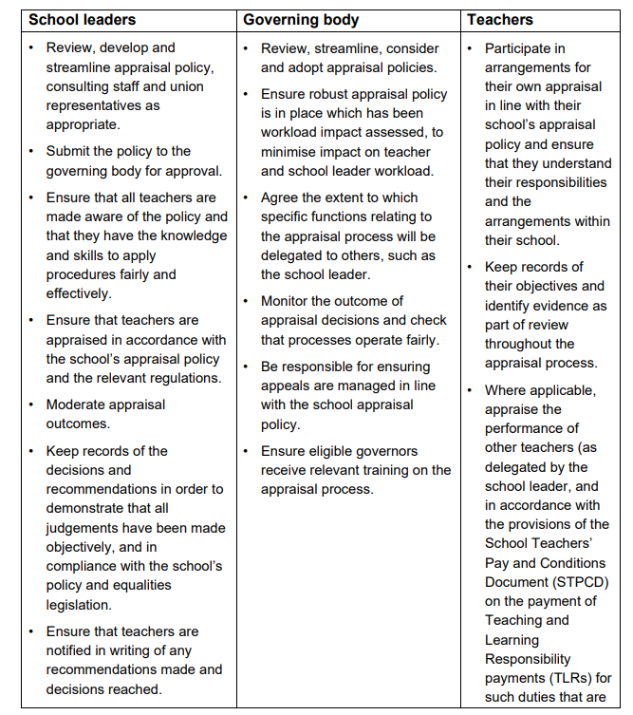
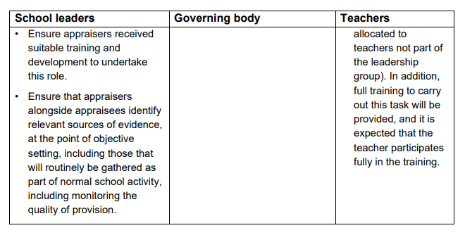

5. Reducing Appraisal Process Workload
“Governing bodies and headteachers, in carrying out their duties, must have regard to the need for the headteacher and teachers at the school to be able to achieve a satisfactory balance between the time required to discharge their professional duties… and the time required to pursue their personal interests outside work. In having regard to this, governance bodies and headteachers should ensure that they adhere to the working limits set out in the Working Time Regulations 1998(20).” (School Teachers’ Pay and Conditions Document, Work/life balance, paragraph 52.4)

A fundamental principle that schools should take into account when developing, implementing, and reviewing pay and appraisal policies is the need to minimise the impact on workload for individual employees. Schools could consider using the workload reduction toolkit.

Schools should always seek to approve policies and processes that avoid unnecessary bureaucracy for all parties concerned; for example, reviewing the process for collecting evidence for appraisal purposes.

Policies and processes should be proportionate and use evidence in appraisal decisions that is readily available from day-to-day practice in school. It should not be necessary for employees to collate large portfolios of evidence for appraisal purposes.

Schools should consider the benefits of using online or electronic performance management solutions to help provide a streamlined approach which can not only reduce workload and save time for employees but can also assist with identifying and targeting CPD needs, empowering staff to take control of their professional growth and allowing leaders to track impact on school priorities.

Schools should ensure that all employees are treated fairly, including those employees who have different working patterns or those with particular protected characteristics under the Equality Act 2010. Employee objectives should be aspirational yet achievable, and based on success criteria which are in their control.

Governing bodies and school leaders also have a duty of care to protect the health, safety and welfare of their staff under the Health and Safety at Work Act 1974 and should ensure staff wellbeing is routinely considered in setting appraisal objectives and making pay decisions.

6. Professional Development - Teaching
The quality of teaching is the single most important in-school factor for improving pupil outcomes – and it is particularly important for pupils from disadvantaged backgrounds. Effective professional development is an integral part of ensuring high-quality teaching that enables teachers to manage teaching and learning effectively. Schools should consider how they establish strong professional development cultures which elevate the quality of teaching and ultimately improve pupil outcomes. Professional development should form a key component of teacher objectives, ensuring their professional practice remains up to date with the latest methodologies, technologies, and educational research.

Professional development is a shared responsibility between the individual teacher and their school. It is good practice for staff and leaders to consider the personal development needs of teachers alongside school improvement needs. The removal of the requirement for performance related pay is to allow schools to have a greater opportunity to focus on professional development in objectives and appraisals.

Schools should identify sufficient resources and support to meet teachers’ and the school’s professional development needs. When they do so, teachers have a responsibility to be proactive in identifying their own needs and utilising all resources and opportunities open to them to meet them (such as collaborating, observing and making use of research). Schools should consider how a teacher is supported to implement learning in their school, and how professional development opportunities taken build on and complement each-other.

As part of facilitating high-quality professional development for teachers and school leaders, schools should consider how National Professional Qualifications (NPQs) can support an individual and school’s development needs. NPQs are part of a wider set of teacher development reforms, running from Initial Teacher Training (ITT) through to school leadership, which root teacher and school leader development in the best available evidence. NPQs provide training and support for education professionals at all levels, from those who want to develop expertise in specialist areas of teaching practice to those leading multiple schools across trusts.

7. Informal Support
Except in the most serious cases of persistent failures to meet job expectations and in the case of teachers the teaching standards, resulting in negative consequences on the pupils and organisation, employees should not ordinarily be placed in capability procedures without first undergoing a period of informal support as part of the appraisal process. It should be made clear to the employee that they are receiving informal support due to performance concerns. At the heart of informal support should be the principle that all employees are expected to achieve satisfactory performance if the support offered is followed. It should be a supportive process, where the facility to talk openly and honestly is central to the process, for both the individual employee and their line manager. The employee may only require focused informal support in a particular area that is aligned with their professional development needs.

This support should have clear, achievable objectives and timelines. The line manager/appraiser should partner with the employee in a collaborative manner to establish objectives and timelines, taking into account the employee's circumstances. This may include any medical conditions, working pattern, well-being support needs, or disabilities protected by equality legislation. The line manager/appraiser is responsible for providing specific feedback, with examples of where standards have not been met, and identifying the appropriate support to help the employee improve. There should be a clear relationship between the issue, the objectives set, and the planned programme of support put in place. The consequences of not meeting the required improvements should be communicated to the employee and confirmed in writing.

Informal support should be provided for a reasonable period (for example a minimum of 6 weeks) to allow for performance improvement. However, the duration should be determined based on the specific circumstances, with appropriate support in place to facilitate improvement. The line manager should meet with the employee regularly to assess progress and ensure the agreed-upon support is being provided.

When progress is reviewed after the defined period, if the appraiser is satisfied that the employee has made, or is making, sufficient improvement, the appraisal process will continue as normal, with any remaining issues continuing to be addressed though that process. If the employee has not made sufficient improvement, then they should be moved into capability procedures.

8. Reviewing Performance

Feedback
Regular feedback is an essential part of managing performance. It provides the opportunity to encourage the employee and identify areas where they are performing well, as well as highlight any areas of concern.

The Headteacher/Line Manager should raise any concerns about an individual’s performance at the earliest possible stage to bring to the employee’s attention that there is a problem, establish the cause of the problem and put in place the necessary support to enable the employee to achieve the required level of performance.

Often this can resolve issues without the need for any formal action.

The employee is also responsible for raising with their appraiser any areas that they have concerns about which may be impacting on their ability to perform.

A Headteacher/Line Manager who has concerns about an employee’s performance should speak to the employee and:

- Explain clearly what the problem is with the current level of performance– give an example but do not be accusatory. Headteachers / Line Managers might find it helpful to use the Problem, Expectation, Gap model (details are available on West Sussex Services for Education under HR Advice, in the Managers’ Toolkit on Poor Performance) to frame the discussion with the employee.
- Explain why it is considered to be unacceptable – explain what the required standard is.
- Find out from the employee what went wrong? / what help they need to do it right the next time? / what is the reason for the poor performance? / What is it preventing them from doing what is required?
- Agree what actions both will take, including offering relevant help and support. What actions they think they can take to help themselves? What actions they think their Head Teacher / Line Manager can take to support them?
- Set the timescale for when improvement will need to be seen by and how you will measure this.
- Explain to the employee that if improvement is not seen within the relevant timescales then there may be a need to move to the formal Capability procedure.
- Clearly document the discussion and agreed actions.
- Review and follow up as agreed.

It may take time to get to the heart of the issue and the solution, as many employees are embarrassed or unwilling to admit that they have difficulties that are impacting on their work. It is important for the Headteacher / Line Manager to enable the employee to recognise that there is a problem and ‘own’ and identify the support they need to meet the required standard.

At meetings under the appraisal policy the employee does not have the right to be accompanied by a work colleague or their trade union representative.

The length of the period given for an employee to improve will depend on the nature of the issue.

Supportive Interventions
The following are examples of further support that can be offered:

Problem | Lack of Training or knowledge | A temporary situation outside work impacting on their performance
Potential Solutions | Training courses  Online courses  Shadowing work colleagues  Mentoring/coaching  Peer Support  Observing a model lesson | Temporary variations to work hours  Temporary variations to work duties  Special leave  Contact the Employee Assistance Programme (details are available on West Sussex Services for Education)  Agreeing detailed action plan to support achievement of targets  Stress risk assessment

Where the school has chosen to retain performance related pay for teachers
Interim Reviews If at an interim review the appraiser would not be able to recommend the teacher for pay progression (because significant progress is not being made against their support plan) then they must advise the teacher that if their performance continues at the current level, they will not be able to recommend pay progression at the end of the year.

Notes of any discussion of this nature must be made (and appropriate feedback should be given to the employee) and supportive interventions should be put in place to help teacher improve their performance.

Concerns Arising After Interim Review
A teacher may be making progress towards their objectives at the interim review, but this may ‘stall’ later in the year.

Where this is the case, the concerns must be raised in feedback to the teacher and the appropriate supportive interventions should be put in place.

If the appraiser feels that the reduction in performance, (should it continue) would impact on their ability to recommend pay progression at the end of the year, this should be raised with the teacher as described above.

Refer to the Model Capability Policy and Guidance. Headteachers/ line managers can obtain further advice from their HR Business Partner or HR Advisor in the HR Business Partner Education Team or contact the team as follows:
Telephone: 033022 22422
Email: HR.Professional.Support@westsussex.gov.uk

9. Document History

Written by: HR Policy and Practice Team (LRW/FR).
Issued: July 2012, revised June 2013 (to take into account changes to STPCD)
Updated: 27/09/2024 TO 18/10/2024 DOCUMENT UPDATED BY KMG HR POLICY TEAM
END OF DOCUMENT

