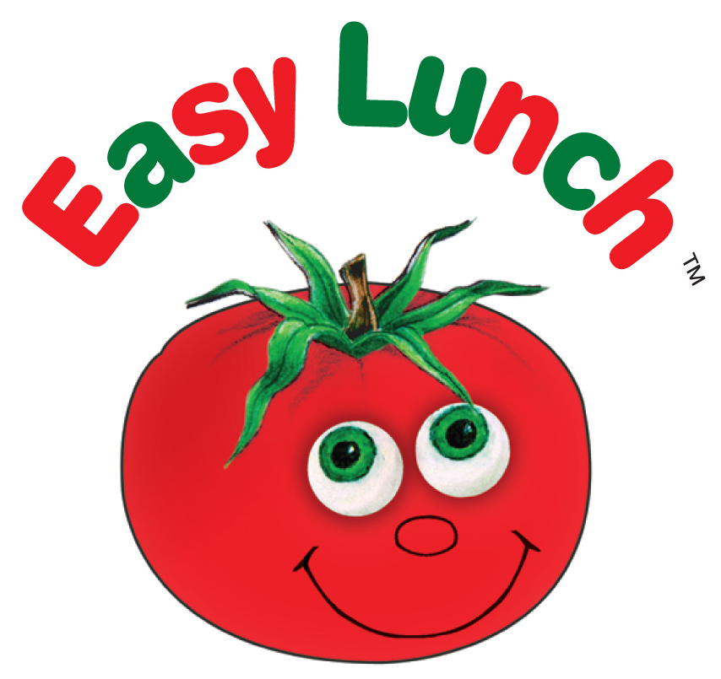
The Easy Lunch Company
01403 741177
23 February 2021

Dear Parents,

Following Boris Johnson’s announcement last night that schools can fully reopen on Monday 8th March – such good news! – I just wanted to remind you to book your lunches online in readiness. The deadline for meals week commencing Monday 8th March is midnight, this Saturday 27th February; some of you may already have your meals booked from when you booked at Christmas which is great however if not please do not delay and book now.

All meals were cancelled from Monday 4th January until Friday 5th March and credits for those meals are on your Easy Lunch account to be used on future bookings.

I will attach an electronic copy of the menu with this newsletter and it is on the website – you should also have been given a hard copy in December when your children broke up for the Christmas holidays, if not please ask your school office for one.

If you are in receipt of Free School Meals in KS2 and need credits on your account so you can choose your own meals you must email me to request credits, at emma@theeasylunchcompany.co.uk. No credits = no meals.

IF YOU HAVE A CHILD WHO HAS A SPECIAL MEAL REQUIREMENT YOU MUST CONTACT ME ASAP IF YOU HAVEN’T ALREADY DONE SO. If you are already registered, you do not need to reapply. For more information, please see ‘How it works’ – Special Diets on our website.

If you have any queries please do not hesitate to contact me on 01403 741177.

Best wishes to you all and I hope the last few days of home school goes smoothly and your children can look forward to being back in school with all their friends.

Emma Treasure

